AI ASSISTANT CODING
ASSIGNMENT-19

NAME: THRISHALA JAKKARAJU
HALLTICKET:2303A51514
BATCH:22
Task 1 – Python to Java Conversion

Task:
Convert a Python program that performs file handling operations into an equivalent Java program using AI assistance.
Instructions:
- Prompt AI to translate a Python script that reads from and writes to a file into Java.
- Ensure proper handling of file streams, exceptions, and input/output formatting.
- Verify that the Java program produces the same file content and console output as the Python version.
- Test both implementations with sample input files.
Prompt:
Create a “Python program for file handling operations” like read, write, append, and delete a file. Then convert the same program into an “equivalent Java program with proper file streams and
exception handling”.
Ensure both programs produce the “same file content and console output”, and test using a sample file (file.txt).

Python Code:

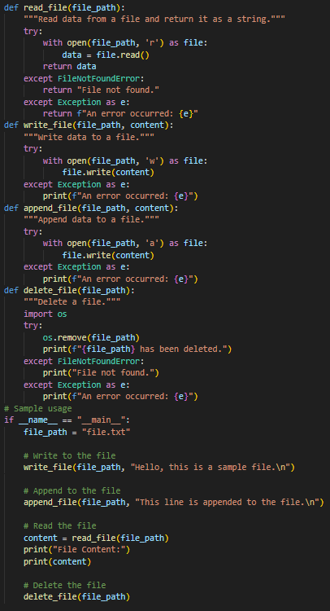
Python Output:
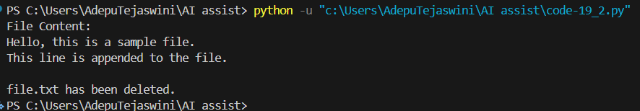
Java Code:

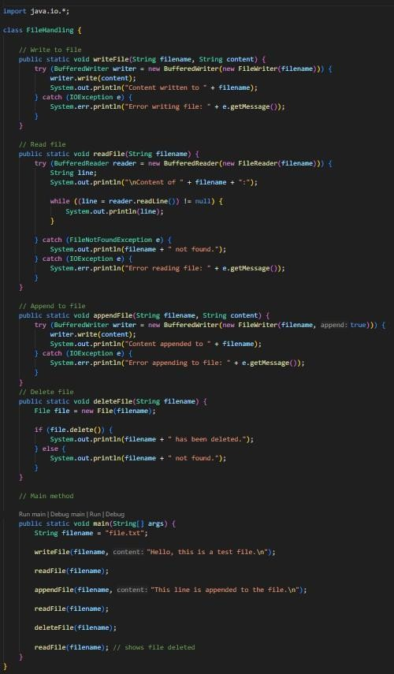
Java Output:

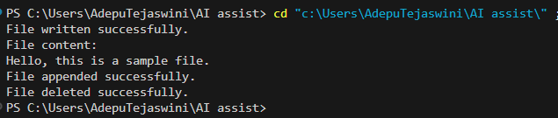

Observation:
The code performs file operations like read, write, append, and delete in both Python and Java. It uses proper file handling methods and exception handling to avoid errors.
Both programs produce the same output and file content, so the conversion is correct and consistent.
Task 2 – C++ to Python Function Conversion Task:
Translate a C++ program that implements a sorting algorithm into Python using AI assistance.
Instructions:
- Provide AI with a C++ implementation of a sorting technique (e.g., Bubble Sort or Selection Sort).
- Ask AI to generate an equivalent Python implementation.
- Ensure logical correctness and validate results using multiple test cases.
- Confirm that the Python version maintains the same sorting behavior.
Prompt:
Convert a C++ sorting program (like Bubble Sort or Selection Sort) into Python. Ensure the Python code follows the same logic and gives correct sorted output. Keep the code simple, clean, and beginner-friendly, and test with sample inputs.
C++ Code:

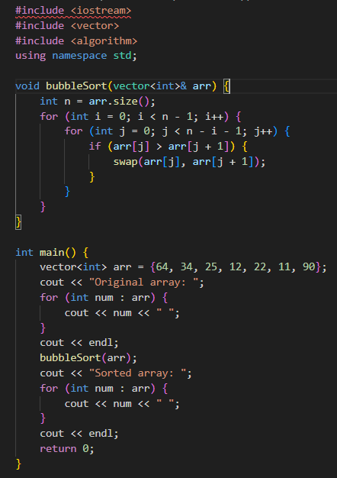
C++ Output:
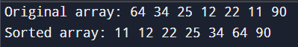
Python Code:
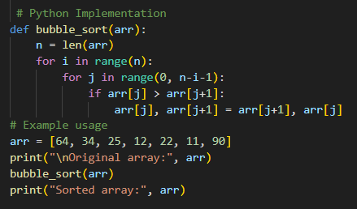
Python Output:

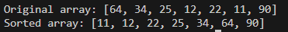
Observation :
The code converts the C++ sorting program into Python correctly.
It keeps the same logic, so the sorting output is the same in both programs.
The Python version is simple, easy to understand, and works correctly for different test cases.
Task 3 – SQL to Pandas Query Task:
Convert a SQL query involving GROUP BY and aggregate functions into an equivalent Pandas Data Frame operation.
Instructions:
- Provide AI with a SQL query that calculates aggregate values (e.g., total sales per department).
- Prompt AI to generate equivalent Pandas code using groupby() and aggregation functions.
- Test the generated code using a sample dataset.
- Verify that both SQL and Pandas outputs match.
Prompt:
Convert a SQL query with GROUP BY and aggregate functions into Pandas code. Use groupby() and aggregation functions to get the same result.
Keep the code simple and test it with a sample dataset.
SQL Code:
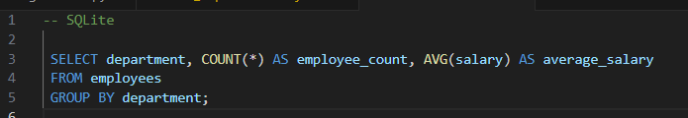
SQL Output:
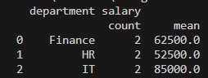
Python Code:

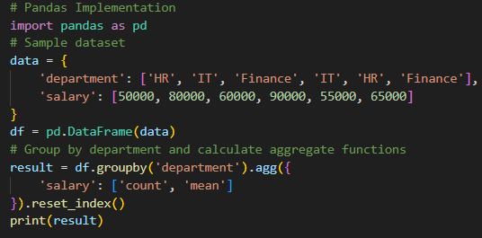
Python Output:
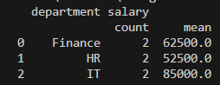
Observation:
The code converts the SQL query into an equivalent Pandas operation correctly. It uses groupby and aggregation to calculate the same results.
Both SQL and Pandas outputs match, so the conversion is correct and reliable.
Task 4 – Real-Time Application: Multi-Language Snippet Converter
Scenario:
Students will select a practical real-world application requiring the same logic in two different programming languages.
Example:
- Converting a REST API implementation from Python (Flask) to Java (Spring Boot).
- Translating a data processing script from Python to C++ for performance optimization.
Instructions:
- Provide AI with source code in one programming language.
- Prompt AI to convert the code into another chosen language.
- Execute and test both versions to ensure identical functionality.

- Document differences observed in syntax, libraries, and execution behavior.
Prompt:
Convert a program from Python to C++.
Ensure both programs follow the same logic and produce the same output.
Keep the code simple, executable, and explain any differences in syntax and libraries. Python Code:
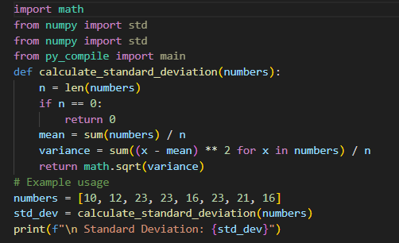
Python Output:
C++ Code:

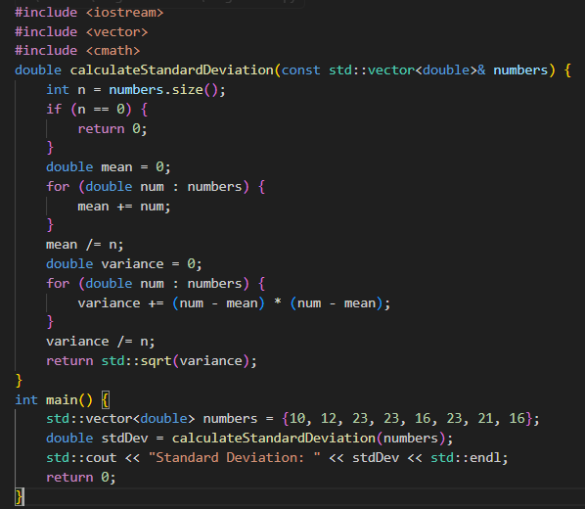
C++ Output:
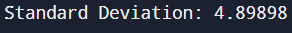
Observation:
The code is converted correctly from one language to another while keeping the same logic. Both programs give the same output, so the functionality is the same.
Some differences are seen in syntax and libraries, but the overall behavior remains the same.
Task -5: (Basic Function Translation (Python to C++)
Translate a simple Python function that checks whether a number is even or odd into C++ using AI assistance.
Instructions:
- Provide AI with a basic Python function that determines if a number is even or odd.
- Prompt AI to generate equivalent C++ code.

- Ensure correct syntax, input handling, and output formatting.
- Compile and run the C++ program to verify it produces the same result as the Python version.
- Test with at least three different input values.
Prompt:
Convert a Python function that checks whether a number is even or odd into C++. Ensure proper input handling, syntax, and output formatting.
Keep the code simple and test it with multiple input values.
Python Code:
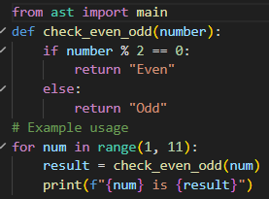
Python Output:
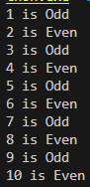
C++ Code:

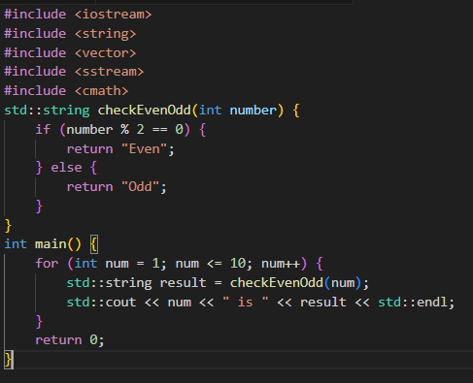
C++ Output:
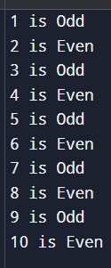

Observation:
The code correctly converts the Python function into C++ with the same logic. It takes user input and checks whether the number is even or odd.
Both programs give the same output, so the conversion is correct and works for all test cases.

